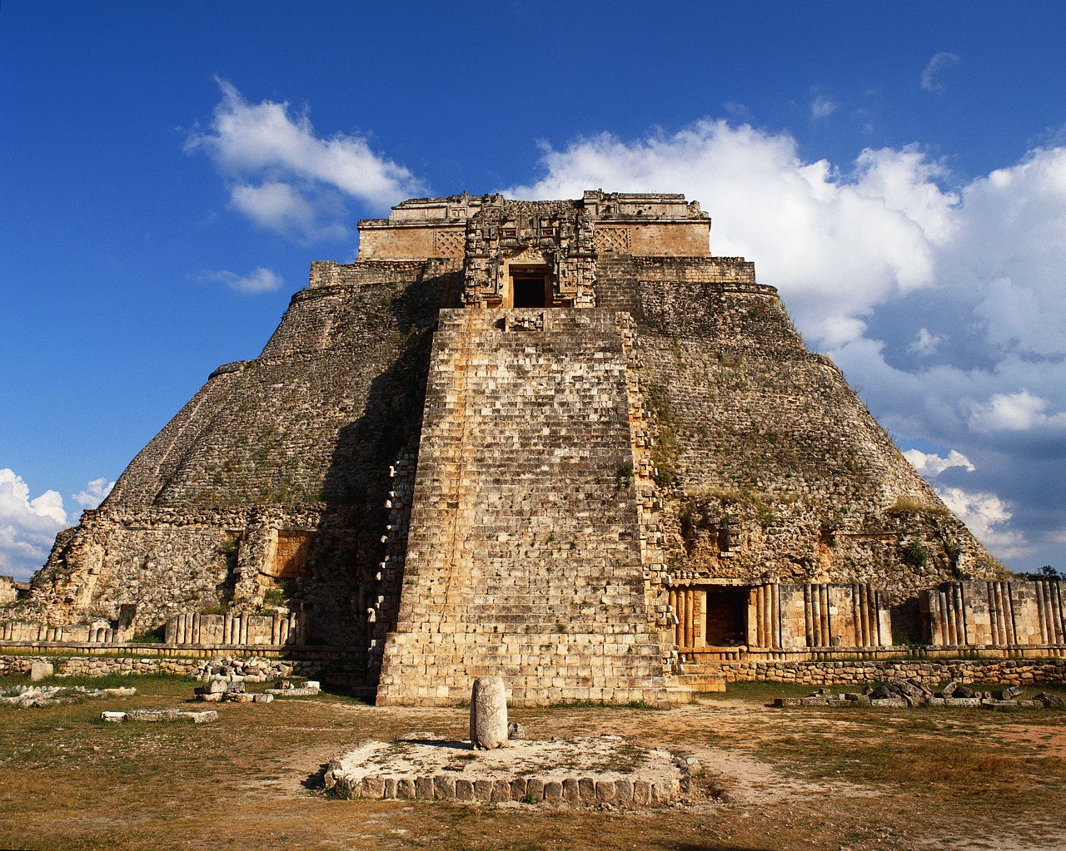
Materials needed: You need to present students with background information on a topic, either through a mini-lecture during which they take notes, or by handing out a fact sheet. Be sure to include visuals. One nice website to help you prepare is www.unmuseum.org. Use the index to search for whatever topic you are interested in. All but two of the topics below can be found on this website.

Description: Present the students with background information on one of history’s mysteries. Some topic ideas are listed below. And on page 2, there is a sample fact sheet about Oetzi the Iceman, one of history’s mysteries.

After you present your mini-lecture or distribute your fact sheet, divide students in pairs. Write modals of possibility on the board, and if you have taught the 2nd and 3rd conditionals by this time, write samples of those as well. This activity is perfect for the use of both modals and conditionals.

Based on what they know of the topic, students can discuss and note possibilities, impossibilities, and conclusions they come up with about the mystery.

The wrap up of this activity can be conducted like an informal debate. For example, one person might say that Oetzi must have been looking for a new home when he got lost. Ask if any student wants to refute that claim. A student might say that he would not have been looking for new home all by himself. He would have stayed with his family or clan.

Sample topics

- Stonehenge
- The Nazca Lines
- The Monoliths of Easter Island
- Atlantis
- The Bermuda Triangle
- The Tunguska Event of 1908
- Loch Ness Monster
- The Death of Oetzi the Iceman
- Bigfoot
- The Oracle of Delphi

Oetzi the Iceman (also spelled Otzi)

- Oetzi is the name scientists have given to a 5,000-year-old body found frozen in the melting glaciers of the Italian Alps. He was found in 1991 by a mountain hiker.

- At the time of Oetzi’s life, Europe was in the Neolithic Period, a time of pre-history, before written language existed in Europe. The Neolithic Age was a time when people domesticated animals, used metal, and grew crops. People lived in permanent, but primitive “houses” in a group -- like a village.

- Oetzi was in his 40s when he died. (Older than the average person at that time.)

- Oetzi was so well preserved that pieces of his leather and fur clothing, waterproof shoes, and weapons have been preserved.

- Physically, tattoos are visible on his skin, whiskers on his chin, nails on his fingers and toes, and undigested food was identified in his stomach.

- His body had more than 50 tattoos. (Why?)

- The food found in his stomach indicates that he ate well -- deer meat and grain.

- He carried with him an ax, a knife, and a bow with a quiver full of arrows. His ax was copper -- an unusual and valuable possession for the time. (Why does he have that?)

- He carried with him a fire-starting kit. (But what would he burn in the snow?)

- DNA tests show that his clothes have traces of blood from four different people. (Whose? And Why?)

- An x-ray showed that Oetzi had an arrowhead in his back, but the arrowhead was not attached to any shaft. (Was he shot? Or did he fall backwards?)

- He also had two broken arrows in his quiver. (How did they break?)

- The vest he was wearing came from a goat that lived in China. (How did he get that?)

- His remains had not been destroyed by animals at all. (Why not?)

- Some scientists think he was a shepherd because his leg muscles indicate a person who walked a lot.

- Other scientists think he was a shaman because of all his tattoos, fine clothes, and unique copper axe.

Information gathered from: http://www.mummytombs.com/otzi/news.htm

