Materials needed: Internet for research or printouts from the websites mentioned below, whatever kind of material you would like students to use for their brochure (foam or poster boards for blow-ups or regular computer paper for electronic jobs, etc.)

Description:

Frequently using the passive voice, the students design a brochure describing an imaginary place, Natura National Park. You need to set up this park in the students’ minds by describing it.

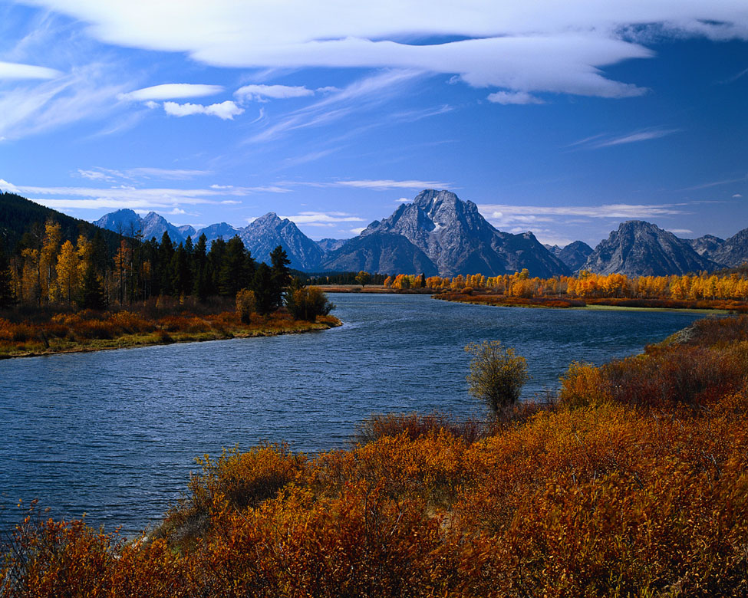
For example: this park has all kinds of natural wonders, waterfalls, mountains, a deep canyon and a rushing river, as well as archaeological sites and prehistoric fossils. Rangers are available for tours and information, and there is a lovely gift shop and museum. Natura Park also has camping facilities and a fun program for children.

After viewing the example pages from Mesa Verde National Park in Colorado, students can design their own brochures for Natura Park. They can incorporate photos copied from online or draw their own. They can take the bare bones of the description of Natura National Park and add whatever creative details they want -- dinosaur footprints, hang-gliding, a diamond mine, white- water rafting, burial mounds, cave art, etc.

Display the finished products so students can view each other’s brochures.

Websites with examples for students:

Mesa Verde Park -- About Your Visit
http://www.nps.gov/archive/meve/park_brochure/p02.htm
(The park is located, the visitor center is found, programs are given, religious services are held.)

Mesa Verde Park – Regulation Page http://www.nps.gov/archive/meve/park_brochure/p11.htm
(Bicycling is permitted, pets must be restrained, lanes are not designated.)

Mesa Verde Park- Attractions
http://www.nps.gov/archive/meve/park_brochure/p03.htm
(The station is staffed, tickets may be purchased, dwellings can be seen.)

Mesa Verde Park- Historical Architecture
http://www.nps.gov/archive/meve/research/historical_arch_main.htm
(The District was built, it was designed, sandstone was used, the ceiling and roof are supported.)

Here are some useful passive constructions students can use to write about natural formations, human impact, and available services.

- Can be viewed
- Is located
- Are found
- Was written/was inscribed
- Was placed
- Was left
- Was formed
- Was built
- Was discovered
- Was designed
- Could have been used
- Are offered
- Was recorded
- Have been photographed

