Materials needed: None

Description: Students write about the qualities and characteristics employment candidates must have for unusual jobs. For interaction and better vocabulary development, have students work in pairs.

Tell the students that these jobs are currently available in your community. They should work with their partners to imagine the skills and qualities required for each job. Write the following list on the board. Students will write a profile of the ideal candidate using the following words and phrases to prompt gerund and infinitive use.

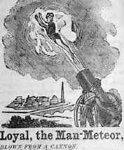
- Skills must include: _____ing, ______ ing, and _____ ing.
- The ideal candidate should enjoy _____ ing.
- The ideal candidate shouldn’t mind ___________ing.
- The ideal candidate must have experience ________ ing
- The ideal candidate will start _________ing immediately.
- The (job title) should agree to __________.
- The (job title) must consent to _________.
- The (job title) should expect to _________.
- The (job title) will be required to ___________.
- The (job title) will need to ____________.
- The (job title) will be permitted to _________.
- The (job title) will be trained to ________.

Job Openings

- Reptile House maintenance at the zoo
- Candy Tester at Goodman’s Candy Factory
- Personal Assistant to a top Hollywood star
- Nanny to two-year-old triplets
- A Human Cannonball in the circus

When everyone is done, share the completed work as a group.

