Materials needed: An authentic article with a good selection of pronouns, such as the one provided below. Except for personal pronouns and many indefinite pronouns, you will have to pre-highlight or underline the pronouns for the students. To avoid confusion, it would be best for you to highlight all the pronouns.

Description: Students read the article in small groups and analyze the use of pronouns. Using their knowledge of pronouns and their grammar text, they can identify antecedents and different types of pronouns. It’s important to use authentic text not written for ESL/EFL students so students can see how antecedents are often not directly stated, and other grammar realities. To keep students focused, you may want to set a list of tasks like --

1. Find a sentence that uses a singular, possessive pronoun. Is it masculine or feminine?
2. What is the antecedent for the plural reflexive pronoun?

Setting the tasks will send them flipping through their grammar books to confirm what they need to know in order to address the tasks.

The article below features:
- subject personal pronouns
- object personal pronouns
- possessive personal pronouns
- relative pronouns
- an indefinite pronoun
- the word “most” functioning as a pronoun when not in front of a noun
- a reflexive pronoun
- a reciprocal pronoun (each other)
- the word one to indicate a single part of a vaguely defined group

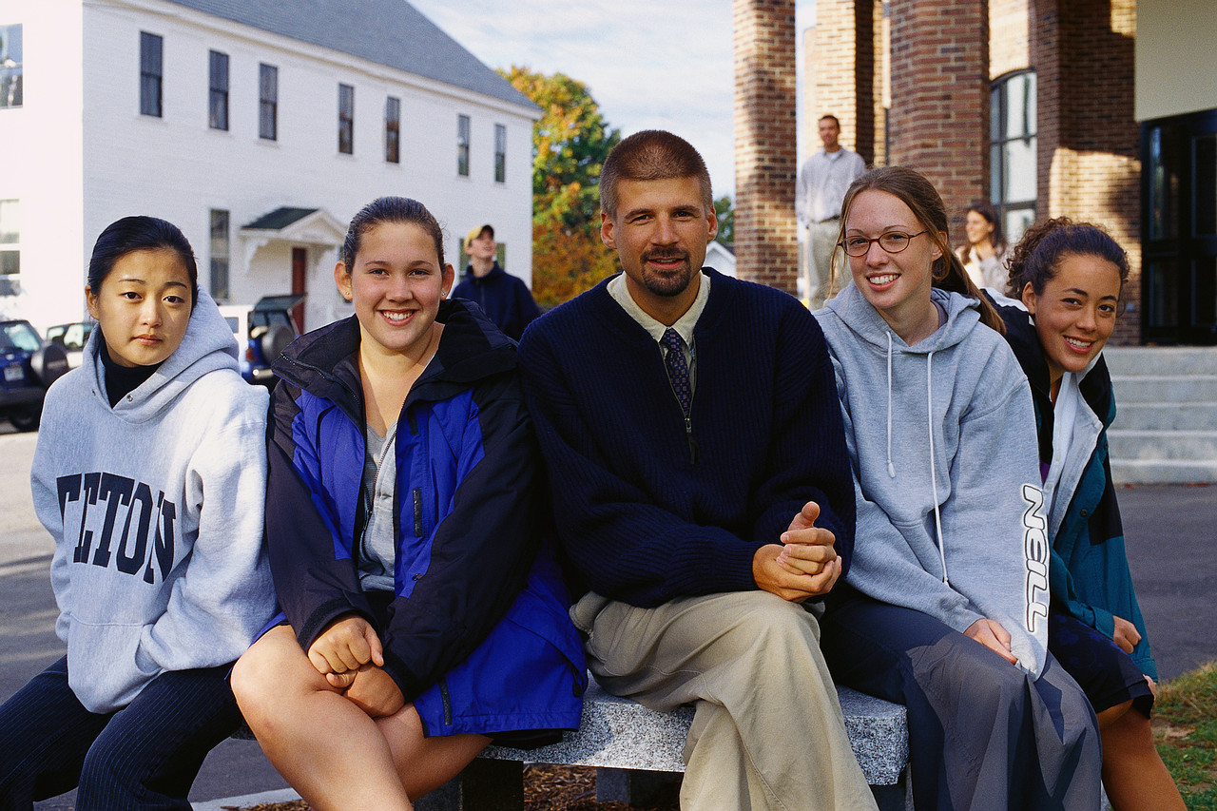

Exchange Students: Promoting Cross-Cultural Understanding
Washington, D.C.
29 August 2006
Representing nations from Morocco to Bangladesh, some 300 students spent their first day in the United States at an orientation session outside Washington.
For some, the trip proved a challenge. Israel's bombing of Hezbollah positions in southern Lebanon complicated the departure of Lebanese students, including 15-year-old Mohamed.
"We left in a helicopter, because there is no airport [open in Beirut]. We left to Cyprus, then to London, then here. We had a really tiring flight," he said.
For most, this is their first time away from home. Much of what they encounter is new and unfamiliar. Perhaps not surprisingly, many students initially clustered together with compatriots to speak their native tongues, which range from Arabic to Bangla to Urdu. After the initial orientation, they were taken on a tour of Washington, including stops at the White House and the Jefferson Memorial.
The students' excitement and sense of anticipation was palpable to anyone who saw them. Among a large contingent from Bangladesh is 16-year-old Faizun.
"It is a lifetime opportunity to come here, to know the [American] culture, to have a close look at the people here, to live with a host family, attend high school. I think it is really nice. It is awesome, " Faizun said.
The Youth Exchange and Study program, called "YES," is operated by a consortium of non-profit organizations with the backing and support of the State Department. Launched in the aftermath of the September11, 2001 terrorist attacks, the program has brought more than 1,000 students, most of them Muslim, to the United States over the last four years.
From Washington, the youths are sent to host families in dozens of American communities, large and small, urban and rural, across the nation.

What do they hope to accomplish during their year in the United States?
"We want to know more about America and its culture, and we want American people to know more about our culture," said 16-year-old Khalil of Yemen.
But Khalil acknowledges he has some apprehensions about challenges he will face. "I think [I may get] homesick, and the language [English]. I think it will be difficult at first. But then we will be staying here for 10 months. I think we will improve our English," he said.
Several students said they want to combat stereotypes some Americans may have about Muslims. Seventeen-year-old Tareq of Jordan said, "Muslims and Middle Easterners are not [all] terrorists. Really. You have to know that we are people. We can think. We are not animals or something."
What good can person-to-person cross-cultural contact accomplish in a world often torn apart by violence and prejudice? No one is pretending that student exchange programs can, by themselves, change the world. But they can and do have an impact, according to an administrator of the YES program, Mary Karam.
"Change happens on a very personal and local level. And this program is one of those opportunities for change, one of those opportunities to take what is going on globally and bring it to a more personal level -- so that people can interact one-on-one and really learn about one another, learn about one another's cultures, and make a difference and move things forward to help build peace in a region that is struggling," said Karam.
Many Americans agree on the need for better understanding among peoples of the world. Margery Silverson of Maryland was at the Jefferson Memorial when the exchange students arrived. "I do not think they [Muslims] are all terrorists and I do not think they should think of Americans as greedy and only out for the dollar [to make money]," she said.
YES administrators say the program can have a lifelong impact on students and their host families. Already, some students from previous years have returned to visit their American families and applied to go to college in the United States. Several host families have also journeyed to visit students in their home countries.
Story found at:

http://www.voanews.com/english/archive/2006-08/2006-08-29-voa73.cfm

