Name ____________________________________

Write a conditional sentence to match the picture. Use the following words.

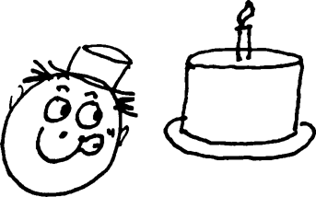
1. ___________________________________________
If + cake / be chocolate
he / eat / it

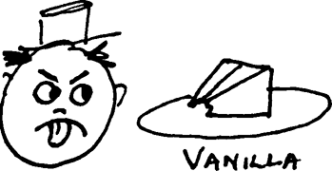
2. __________________________________________
If + cake / be chocolate
he / eat it

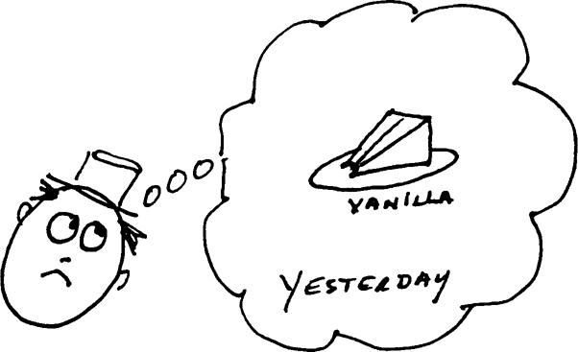
3. _______________________________________ If + cake / be chocolate
he / eat it

