Name _________________________________

Write a conditional sentence to match the picture.

shoe store
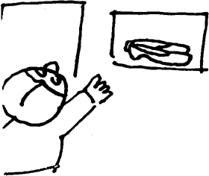
1. __________________________________________
If + shoes fit / she / buy them

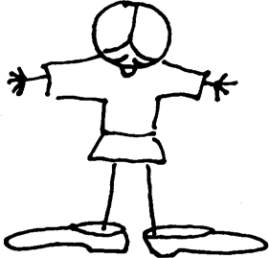
2. ________________________________________
If + shoes fit / she / buy them

(Too Big)

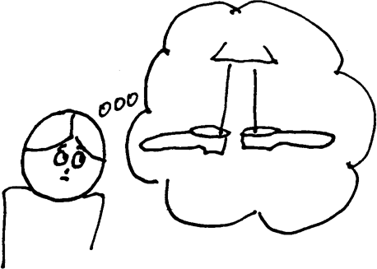
3. ____________________________________
If + shoes fit / she / buy them
yesterday

