
Materials needed: A selection of newspaper cartoons with the text whited out, or images of people interacting in interesting situations. Prepare non-cartoon images by drawing speech bubbles on them for each character in the cartoon. An animal can be an interesting character with a thought bubble instead of a speech bubble. The Cartoon Factory at http://www.nationalgeographic.com/kids/games/ (scroll down halfway in the center) offers many images that can be completed online and/or printed out.

Description: Using Summary Chart 13-8 of modal auxiliaries as a guide, students create the text for cartoons. Hand out a few text-free cartoons to pairs of students and encourage them to use at least one modal for each cartoon. Display or otherwise share all the cartoons at the end. An alternative is to photocopy and use the same several cartoons for each pair and compare the varieties of language used by each pair.

Here’s a sample using the targeted modals:

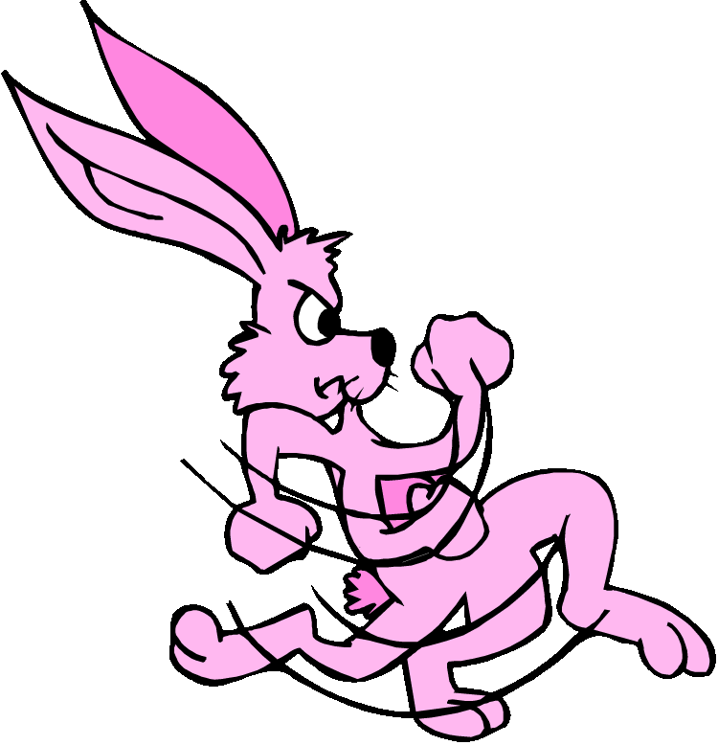
Hmm…I think
I might have a
little snack….

Oh no! I’d better get out of here!
