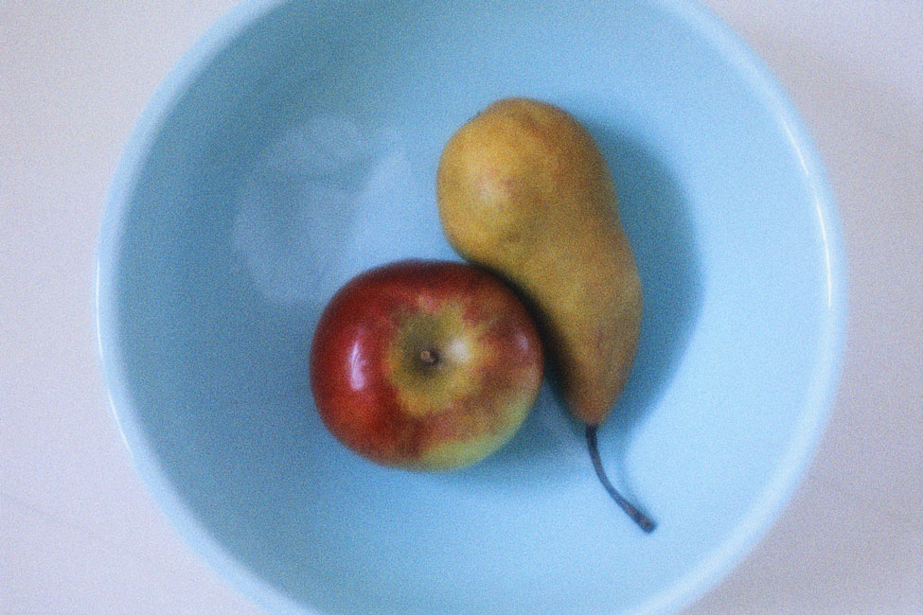
Materials needed: A large assortment of pictures of people, places, animals, and objects. Cut out pictures from magazines and catalogs. Categorize the pictures into four groups: people, animals, places, objects. You’ll need at least two pictures from each category for each group of three or four students.

Description: In this small-group activity, students try to find ways to compare two pictures. Split the class into small groups and hand out at least two pictures from each category to each group. Using the target language of comparison (-er, more, alike, similar), students should think of as many ways as possible to compare each pair of pictures from each category. One person in each group should write down the sentences the group generates. Don’t worry about finding similar objects, like two different cars or two different houses. If objects are different, it is more creatively challenging for students to think of ways to compare.

For example:

Category: Places (similar places)

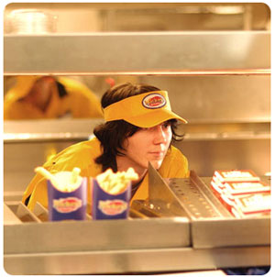
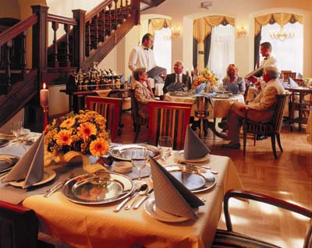

The fast food restaurant is cheaper than the nice restaurant.
The fast food restaurant is more unhealthy than the nice restaurant.
The nice restaurant has a prettier design than the fast food restaurant.
The waiters in the nice restaurant are friendlier than in the fast food restaurant.
The two places are alike. People can eat there.

Category: Objects (very different objects)

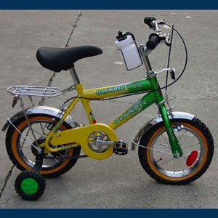
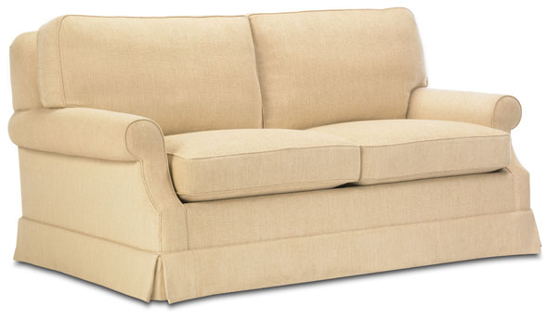

The bike is cheaper than the sofa.
The sofa is larger than the bike.
The sofa is more comfortable than the bike.
The bike is more colorful than the sofa.
The two things are alike. People can sit on them.

When students think of several comparisons for each pair of their pictures, they can trade pictures with the group next to them and repeat the process. At the end of the activity, both small groups can get together and compare the sentences they came up with for all their pictures.

