Adjective Mix and Match

- Draw a line from each adjective to its opposite.

Hot healthy
Intelligent poor
Big cold
Rich small
Sick stupid

- Draw a line to the picture that best matches the adjective.

Old happy tired fast

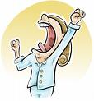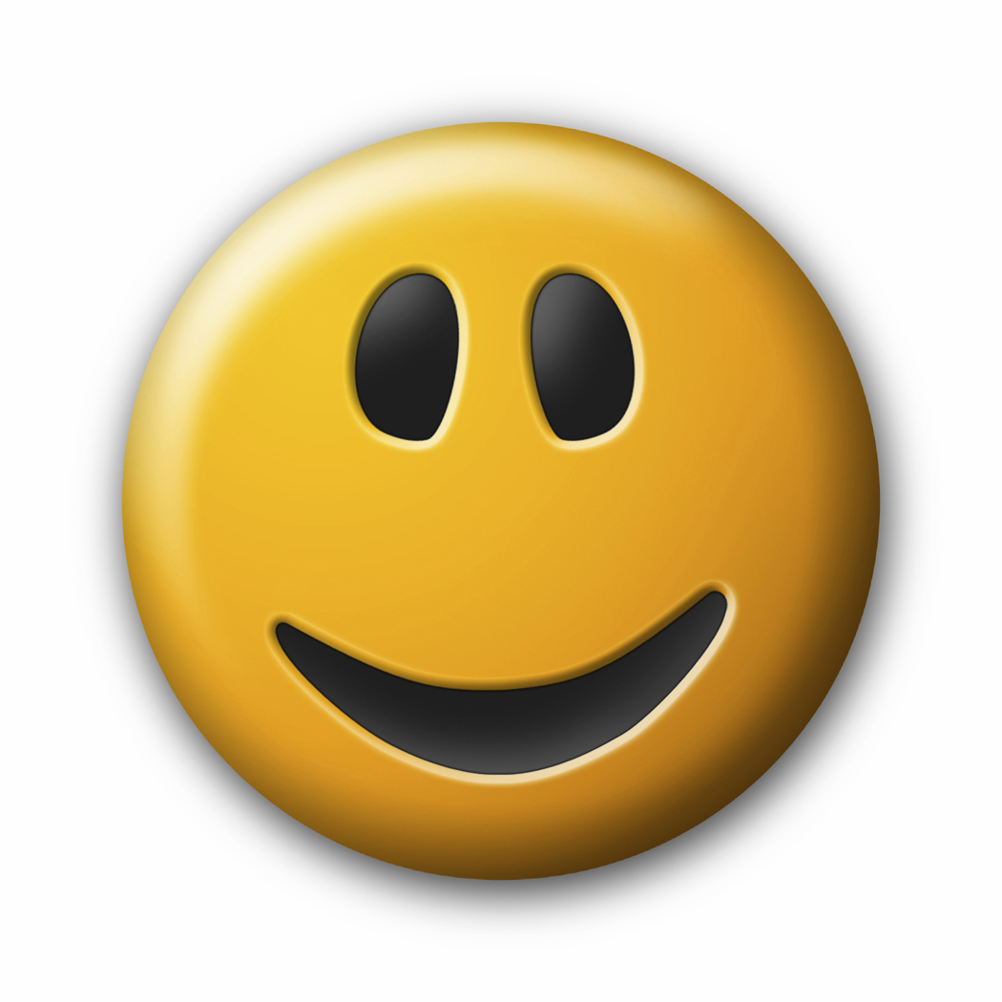

- Write a sentence using each adjective in the box.
cold short open young new

1.

2.

3.

4.

5.

