Comparatives and Superlatives Assessment
- Write a sentence using a comparative adjective about the following pictures. Use than.

- 
Dave Frank

- 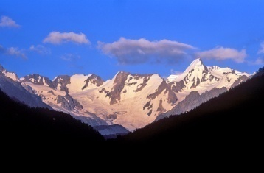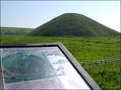
Mt. Everest Sidbury Hill

- Write a sentence using a superlative adjective about the pictures below. Use the.

- 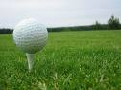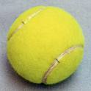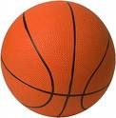
Golf ball tennis ball basketball

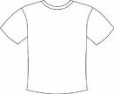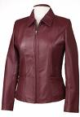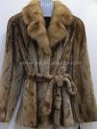
T-shirt leather jacket fur coat

- Fill in the blanks with the comparative or superlative form of the adjective in parentheses. Be sure to use the before superlatives and than after comparatives as needed.

Ex. | The cheetah is the fastest terrestrial animal in the world. | (fast)
Ex. | Nepal is smaller than Tibet. | (small)
1. | Do you think Fanta is Coca-Cola? | (tasty)
2. | I think that water is drink of all. | (refreshing)
3. | She is person I have ever met. | (nice)
4. | An ice cream sundae is than a brownie. | (delicious)
5. | The story of “Little Red Riding Hood” is ________________ the story of “The Three Little Pigs.” | (interesting)
6. | desert in the world is in Chile. It is the Atacama Desert. It never rains there. | (dry)
7. | My pet hamster is my brother’s pet iguana. | (fat)
8. | Texas is famous for barbeques in the USA. | (good)
9. | My grade on this test is last week’s test. | (bad)
10. | An IPOD is a radio. | (expensive)
11. | Helium is hydrogen. | (light)
12. | The Mediterranean is sea in the world. | (large)

- Fill in the blanks with a comparative or superlative adjective to complete the following paragraph.
Ms. Cohen has two children, Arizona and Hanan. Arizona thinks he is _______________ (smart) than Hanan, but he’s not. Hanan thinks he is _______________________________ (handsome) than Arizona, but he’s not. Both of her children think they are _________________ (good) than their brother. Ms. Cohen has to remind her children that she is the ________________________ (intelligent) person in the family. Even though she is the _______________ (short) person in the family, she is the _____________ (cute).

