QUIZ 6A: Comparatives and Superlatives

Look at the pictures. Complete the sentences by using the correct COMPARATIVE (–ER THAN, AS… AS) or SUPERLATIVE (THE… –EST ) forms of the words in the box.
good – bad fast – slow large – small

- Andrew’s grades are ______________________________ Carolina’s.
- Carolina’s grades aren’t ___________________________ Clark’s.
- Andrew’s grades are ______________________________ of all.
- Clark’s grades are ________________________________ of all.

- Lisa’s car is __________________________________ Charlie’s.
- Charlie’s car isn’t ______________________________ Johnny’s.
- Lisa’s car is ___________________________________ of all.
- Johnny’s car is _________________________________ of all.

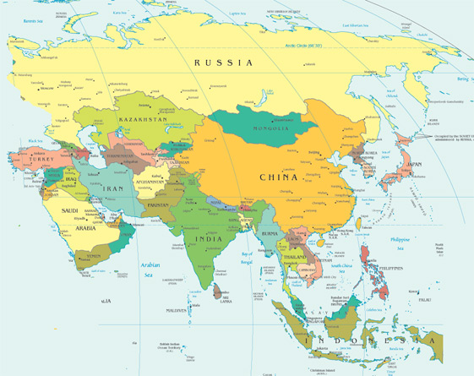
RUSSIA

JAPAN
CHINA

- Russia_____________________________________ China.
- Japan isn’t ____________________________________ China.
- Russia is ______________________________________ of the three countries.
- Japan is _______________________________________ of the three countries.

