Error Analysis

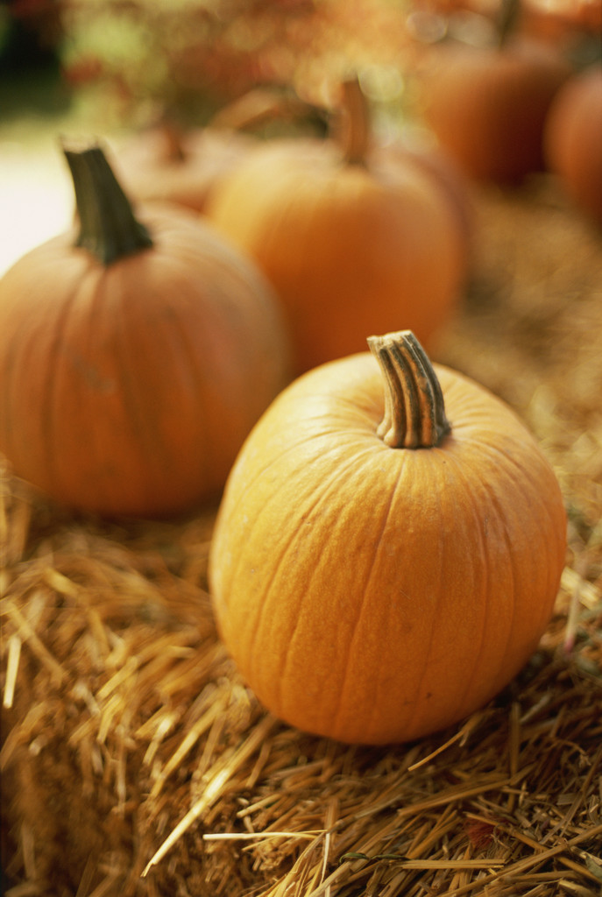

Correct the errors. Rewrite the sentence with correction(s).

- Innsbruck is city in Austria.
____________________________________

- Cats is animals.
____________________________________

- A bee is a insect. It makes honey.
________________________________________

- The students are happy. They has a class now.
__________________________________

- Louis have two brothers.
________________________________________

- We are n’t sad. We are sick.
________________________________________

- My friends ‘re from Russia.
________________________________________

- My papers on the table.
________________________________________

- Mr. Swakee is a teacher?
________________________________________

- Her gloves is in the drawer.
________________________________________

- I have they book here.
________________________________________

- I has my book here.
_________________________________________

- My hands are very colds.
_________________________________________

- This girls are from China.
_________________________________________

- These pumpkins is my.
_________________________________________

Myra M. Medina
Miami Dade College

