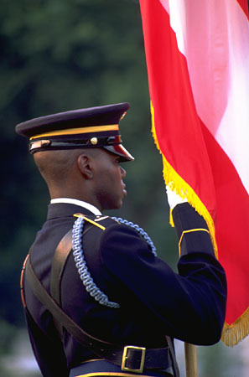 The Fourth of July
"Do" and "Does" Review

Directions: Read the following sentences. Create questions using "do" and "does".

- _______________________________________________?
Yes, they do. They celebrate their independence on the 4th of July.

- _______________________________________________?
Yes, it does. The American government gives the day off to most workers.

- ________________________________________________?
Yes, they do. Most people watch fireworks on the night of the 4th.

- ________________________________________________?
No, it doesn't. My home country doesn't celebrate independence on this day. We celebrate on a different day.

- _________________________________________________?
Yes. I plan to have a barbeque this year to celebrate July 4th.

Professor Kelly Kennedy-Isern
Miami Dade College

