King Tutankhamun

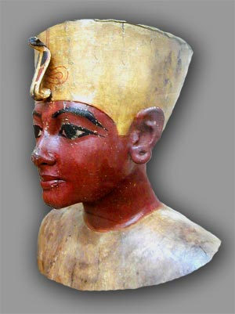
Directions: Change the statements to questions using the interrogative given.

1. King Tut was a pharaoh in Egypt.

Who .

Where .

2. The museum has a four-month exhibit with 130.

What

How many

- The pieces are usually at the museum in Cairo.

What

Where

4. Howard Carter discovered the pharaoh’s tomb in 1922.

Who .

When .

5. In his tomb, there was an elaborate treasure.

What .

Where

6. King Tut died at the young age of 18 or 19.

How old

7. Some people believe he was murdered.

What

Myra M. Medina
Miami Dade College

