Worksheet 4. Adjectives

Complete the sentences with words from the word pool.

crowded empty full


- The mailbox is ______empty___________.

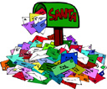
- The mailbox is ___________________.


- The bus is ______________________.

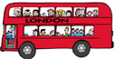
- The bus is full. It is ________________.

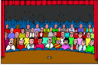
5. The theater is full. It’s _________________.

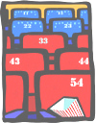

6. The theater is ___________________.

