Worksheet 9. Geography words, page 1

Choose the correct word or phrase to complete each sentence.

Chile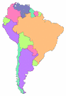Brazil
Argentina

MAP OF SOUTH AMERICA

1. South America is __c_____.
a. a city b. a country c. a continent d. an island

2. Chile, Argentina, and Brazil are _______ in South America.
a. cities b. countries c. islands d. continents

3. On the map, Brazil is _______.
a. short b. tall c. long d. large

4. On the map, Chile is _______.
a. large b. tall c. long d. square

5. Argentina is _______ Chile.
a. in b. on c. under d. next to

6. Argentina is _______ Chile and Brazil.
a. under b. below c. between d. in

Worksheet 9. Geography words, page 2

MAP OF CANADA

NORTH
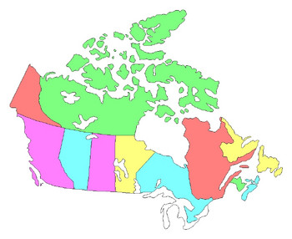

WEST EAST

Pacific Atlantic
Ocean Ocean

Vancouver Montreal

United States

7. Vancouver is __a_____ Canada.
√ a. in the west of b. between c. next to d. in the east of

8. Montreal is _______ Canada.
a. in the west of b. between c. next to d. in the east of

9. Vancouver and Montreal are _______.
a. countries b. islands c. cities d. continents

10. Vancouver and Montreal are _______ Canada.
a. next to b. in c. in d. above

11. The land of Canada is _______ Montreal and Vancouver.
a. between b. next to c. in d. on

12. Canada is _______ of the United States.
a. north b. south c. east d. west

