Worksheet 3. Reading: Johnny Appleseed

Read the passage. Then answer the questions on the next page.

Johnny Appleseed


Johnny Appleseed was an American pioneer* and a legend. He loved apples. He grew apple trees and traveled around many places in the United States of America to bring apple trees to the people. Many people think that Johnny Appleseed was an imaginary character, but he was a real person. He was born in Massachusetts in 1774 and lived for 70 years.

Johnny had good farming skills. He planted apple trees and took good care of them. He supplied apple seeds to the early settlers in the Mid-west of the USA, the large part of the land in the middle of the country, far from the oceans. He owned tree farms in several states. He sold many trees, but gave away many, too. He was very successful, but he lived a simple life. He was kind and generous and friendly to everyone. And he did funny things! He liked to walk in his bare feet, and he wore his tin cooking pot on his head as he traveled.

His real name was John Chapman, but people called him Johnny Appleseed because of his great love for apples and their seeds. Johnny spent 50 years growing apple trees and spreading them successfully all over the land.
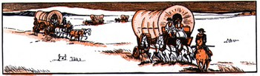
*The people who traveled west in the United States and made their homes in new places were called pioneers.

Worksheet 3, page 2

Circle True if the sentence is true, and False if the sentence is false, according to the passage about Johnny Appleseed.
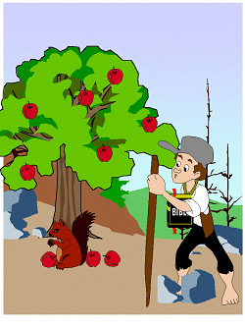

1. Johnny Appleseed was a real person. | True / False
2. He traveled in the eastern part of the USA. | True / False
3. He grew vegetables and sold them. | True / False
4. He was unsuccessful. | True / False
5. He was generous and nice. | True / False
6. He always wore shoes. | True / False
7. He wore a hat that was really a pot. | True / False
8. He spread apples and apple trees all over the  country. | True / False

