Worksheet 4. Vocabulary review

Complete the sentences. Circle the correct word in parentheses.
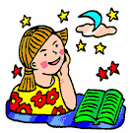

1. Something that is not real and is only in your head is (true/ imaginary).
- An popular old story that may be true, or not, is a (fact / legend)

- A person in a book, a play, or movie is a (character / comic).

- Farmers (buy / supply) food to the markets.

5. People call the land that is not near the Atlantic Ocean or the Pacific
Ocean, but is in the middle of the United States, the (Midwest /
Midnorth).

6. A person who is nice to other people and cares about them is (kind /
funny).

7. If you (own / owe) something, it is yours. It belongs to you.

8. Flowers and plants grow from (seeds / fruit).

9. People who are the first to live somewhere are (settlers / cooks).

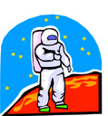
10. (Tiny / Great) means very large.

11. Neil Armstrong, the first man on the moon, was a kind of (pioneer / farmer) in space travel.

