Worksheet 5. Vocabulary review

Complete the sentences. Choose the correct word from the word pool and write it in the blank space.

away bare care generous pot simple
skills spread successful tin


1. When you get the result you want, you are
____________________.

2. Parents take ____________________ of their children.
3. Something that is easy to do is ____________________.
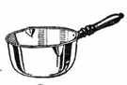
4. A person who is willing to give time, money, or things to others is
a ____________________ person.

5. You cook food in a ____________________.
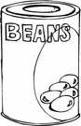
6. Cans with food in them are ____________________ cans.

7. I got my hat from Aunt Bessie. She gave ____________________
all her old hats.
8. Things that you do well are ____________________.
9. Fire quickly ____________________ through the building.
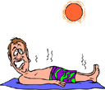
10. The sun burned his ____________________
skin.

