Worksheet 2. Reading: Games

What game is it? Guess the name of each game and write it in the blank space.

backgammon cards checkers chess marbles

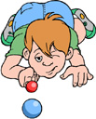
Games
1. This game originated in ancient Rome. It is one of the most popular games of children all over the world. You play the
game with small colored balls, made of glass or another hard material, and you play it while you are sitting or lying on the ground. This game is ________________________.

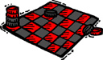
2. This game originated in Egypt over 4,000 years ago. You play this game on a board. The board has red and black
squares. You move round pieces of wood or plastic around
the board. This game is ____________________________.

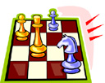
3. In modern times, we associate this game with Russia, but
we don’t know where it originated. It could be China, or India, or
Ireland, or the Arabian peninsula. You play this game on the
same board as the game in the first question, but the pieces of the game are different. The pieces aren’t round, but instead, they are of several different shapes. Each piece can move differently, and some pieces are more valuable than others. This game is ___________________.
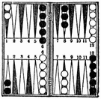
4. This game is the oldest known game on earth. It originated
in the area that is now Iraq, Iran, and Syria. You play this
game on a board with narrow, colored triangles on it, and
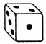
you move the round objects according to the numbers on
the dice. This game is _______________________.

