Worksheet 4. Comparisons

Complete the sentences. Choose the correct word from the word pool and write it in the blank space.

alike efficiently famous like modern
older spacious tiny

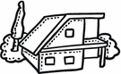
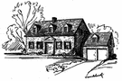
1.

A B

House A is traditional, but House B is ______________________________.
These houses are not _____________________.
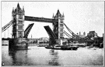

2.

C D
Bridge C is __________________________ Bridge D because both are ____________________________. But Bridge D is ________________
than Bridge C.


3.

E F

Car E is my neighbor’s car. It’s more _______________________ than Car F, my car. It’s more comfortable, too. My car isn’t big. In fact, my car is ____________________, but it is fine. It uses gas
very _______________________________.

