Worksheet 13. Clothes, shapes, parts of the body

Cross out the word that is incorrect in each set of parentheses.

collar
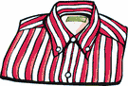

1. This is my new shirt. It has gray and white (spots /
stripes). It has a (necklace / collar) with (buttons /
earrings).

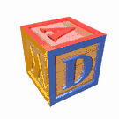

2. This is a block. It has 6 sides. Each side is a (square / circle).
This block has a letter on each side. It has a D on one side, and
an A on the (top / bottom).

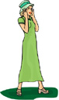

3. This is my sister. She is wearing a (long / short) green (dress /
suit). She is wearing a hat on her (hand / head).

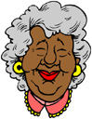

4. This is my mother-in-law. She is wearing gold (buttons / earrings) on
her (eyes / ears).

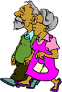
5. These are my grandparents. My grandpa has a gray (beard /
ear) on his face. He is wearing a (dress / shirt) and a (sweater
/ hat). He has dark brown (shoes / pants). My grandma has
gray (hair / eyes). She is wearing a (pants / dress). She has a
white (briefcase / purse) in her (left / right) hand.

