Worksheet 2. Colors

What color are these foods? Write the name of each of these foods in the correct row.
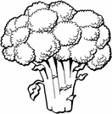
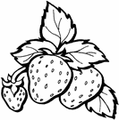

broccoli
butter
carrots
chocolate
coffee
lemons
lettuce
milk
orange juice
strawberries
tomatoes
yogurt

Red

Orange

Yellow

Green

Brown

White

