Worksheet 8. Days and months

Complete the sentences. Write in the correct word. Use one of the words in the reading passage, or one of these words: after, before, between, first, last, middle.

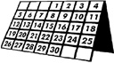

The days of the week are Sunday, Monday, Tuesday, Wednesday, Thursday, Friday, and Saturday.

- A week has seven _____________________.

- Tuesday is between Monday and _____________________.

- Saturday is after ______________.

The months of the year are January, February, March, April, May, June, July, August, September, October, November, and December.

- A year has twelve _____________________.

- February is _____________________ January and March.

- April is _____________________ March.

- November is _____________________ December.

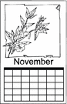
8. The calendar says it’s November. November has 30 days.
November 1 is the _________________day of the month.

9. November 30 is the ___________________day of the month.

10. November 15 is in the _____________________ of the month.

