Worksheet 6. Verbs: Animal activities

Complete the sentences. Circle the letter of the phrase that completes each sentence correctly.
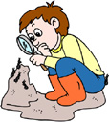
ant
1. Ants are small insects. They ________.
a. jump over water b. crawl on the ground c. swim under grass

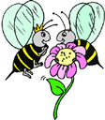
2. Bees are insects. They ________.
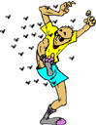
a. swim in the water b. crawl on ice c. fly in the air

3. A bee sometimes ________.
a. feels a person b. stings a person c. speaks to a person

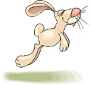
4. Rabbits _______.
a. fly over the water b. jump over the grass c. swim under
lakes
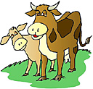
5. Cows _______.
a. give milk b. run fast c. have stripes

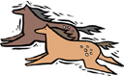
6. Horses _______.
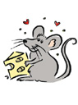
a. have wings b. run fast c. have

7. A mouse doesn’t _______.
a. run fast b. eat cheese c. make a loud noise

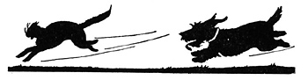

8. Dogs often _______.
a. climb trees b. chase cats c. sting people

