Worksheet 6. Verbs: Nouns and prepositions

Complete the sentences. Write the correct word from the word pool in each blank space.

Susie is at the zoo. She sees these animals.

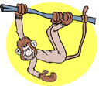
holding hanging watching around under

1. A monkey is __________________________________ from a branch on a tree. He is ______________________ the branch with his left hand and his two feet. His tail is
_______________________________ the branch.

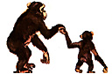
learning teaching standing hands faces

2. These chimpanzees are ________________________ on two legs. The mother is ________________________ her baby how to walk. The mother and the baby are holding ____________.

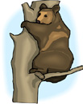
below around branch leaf climbing sitting

- A brown bear is _____________________________ a tree. His arms are _______________________________ the tree. He is _____________________________________________
on a _____________________________ of the tree.
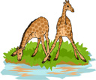

drinking seeing looking water grass

4. Two giraffes are standing on the ____________________ next to the ____________________________. One giraffe is bending his head down and ___________________________. One giraffe is turning his head to the left and ______________________ around the area.

