Worksheet 4. Common nouns

Complete the sentences with a word from the word pool. Write the correct word in each blank space.

apple boys breeze buildings information person
problems restaurant traffic vegetables

1. This is a delicious _______________________!

2. Pay attention! The professor is giving us important __________________.

3. Susan understands the problem. She’s an intelligent _________________.

4. I buy fresh _______________________ at the market on Saturdays.

5. It’s a beautiful day! The sun is shining, and there’s a nice
_______________________.

6. Johnny and Scotty are little __________________. They’re five years old.

7. Our favorite _______________________ is now open on Sundays. We
like to have dinner there on Sunday evenings.

8. There’s heavy _______________________ on the highway in the
mornings.
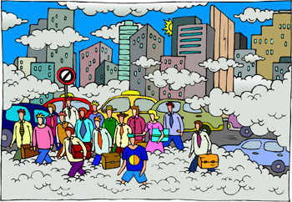
- Instead of small stores, there are now tall ______________________ around the park downtown.

- Smog causes serious
_______________ in some places. The air is not clean.

