Worksheet 8. Singular and plural nouns

Write the words that the numbers point to. The first letter is given.

1. 2. 5. 6.

3.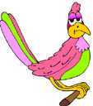 . 7. 9.

8.

4.

A bird has:

a tail with f ______________.

- a b ______________.

- two w ______________.

- c ______________ at the bottom of their legs.

A person has:

- two h _____________.

- two e _____________.

- two k _____________.

- two f _____________.

- a c _______________.

