Worksheet 8. Housekeeping activities
Complete the sentences below the picture of the house. Circle the correct word in the parentheses. Use the information in the picture.

roof

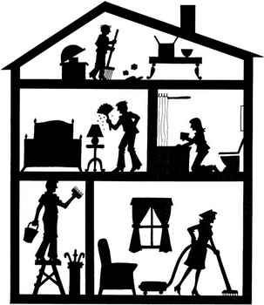
broom

trash can
attic

bedroom bathroom

bathtub
bed
toilet
lamp
living room

hall
curtains
pail vacuum

ladder

- The roof is (over / under) the house. It is (outside / inside) the house.

- In the attic, Sam is (painting / sweeping) the (floor / ceiling) with a broom. The trash can is (open / closed).

- In the bedroom, Paul is (washing / dusting) the lamp.

- In the bathroom, Kathy is (cleaning / sweeping) the bathtub. She is (standing / kneeling) at the side of the bathtub, and the toilet is (in front of / behind) her.

- In the hall, Carl is (standing / sitting) on a ladder. He is painting the walls and the ceiling. He has a (mop / pail) in one hand.

- In the living room, Susan is (vacuuming / painting) the floors. There are curtains on the (door / window).

