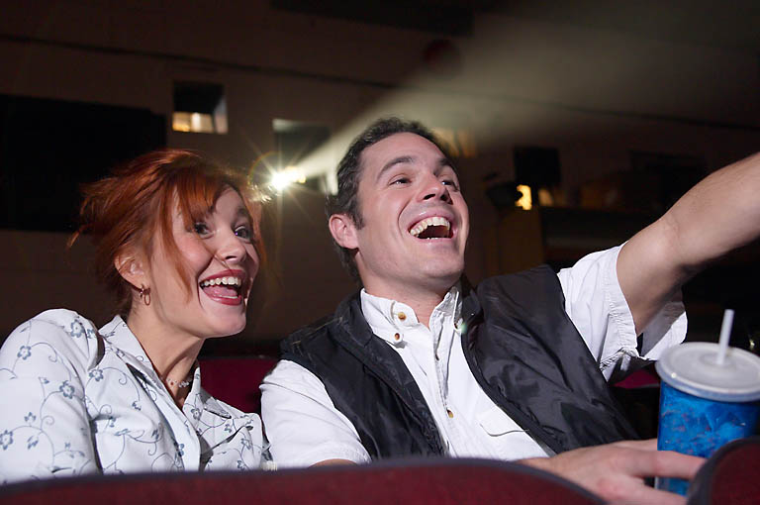
Materials needed: A short movie or TV show that hinges on action rather than dialogue.

Description: In this activity, students are encouraged to use will, be going to, and modals of possibility, as well as the phrase be about to, and the words maybe and probably.

Students watch a movie. Pause the movie at pivotal moments and asks the students to guess what is going to happen next. Students can predict what follows in that scene, or in the next scene.

Whatever video is shown, it should be strongly visual and have some unpredictable physical action. Slapstick-style humor, with falling flowerpots and people slipping on banana peels, works, as do kids’ cartoons. Jimmy Neutron is a children’s animated show that is excellent because it is all very unpredictable and has brief 15 minute episodes that can be shown in their entirety. Other movies that work well are Mr. Bean, parts of Pink Panther movies, and pre-teen movies like RV, Zoom, Spy Kids, and Sky High.

