Materials needed: A page of paired pictures, sets of connecting words on small slips of paper.

Description: Students have to use a random connecting word to create a relationship between the objects or the scenes in two pictures.

Write the connecting words from Chapter 8 on individual pieces of paper.

and but or so neither either because although even though too

You can create several complete sets of these words so there is a set for every three or four pairs of students. Place the set of papers near the pairs of students. Give each student the handout of the pairs of pictures. Each pair of students chooses a word slip and tries to make a relationship sentence linking the first pair of pictures. A sample page of pictures is provided on the following page.

This activity requires great creativity and lateral thinking, and even students who randomly pull the same word for the same pair of pictures won’t come up with the same relationship.

Example: Use the word so-

Students might say “A computer is a useful tool, and so is a hammer.”

Or if the students pulled the word because --
“You shouldn’t use a hammer around a computer because a computer is fragile.”

Or if the students pulled the word but --
A hammer doesn’t need electricity, but a computer does.

With the word neither --
“A computer isn’t used to clean the kitchen, and neither is a hammer.”

1. 



2.

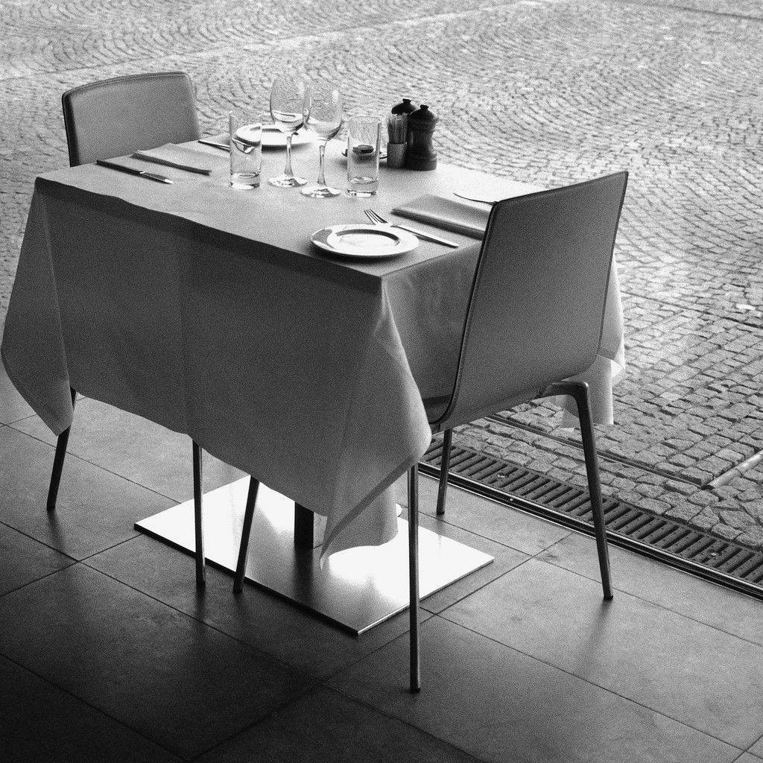

3.



4.



5.

6.

