Name ______________________ Date _____________

Go + -ing – Activities

Directions: Look at the pictures and the words in parentheses. Write sentences using go + -ing.

- (Ron, run, treadmill, everyday)

____________________________________________________.

- (Karen, jog, park, Sundays)

________________________________________________.

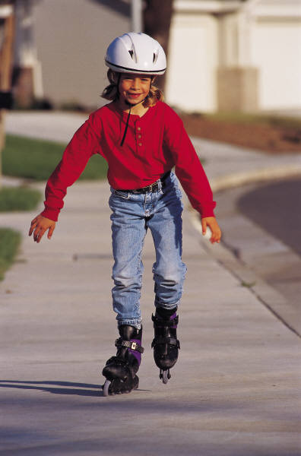
- (Katie, rollerblading, sunny days)

________________________________________________.

- (The Smiths, ice skating, cold weather)

________________________________________________.



- (John, sailing, every week)

_____________________________________________________.

Kelly Kennedy-Isern
Miami Dade College

