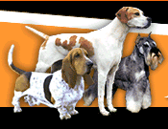
DOGS

I like dogs very much. They are beautiful and friendly. They are good company for you and your family. There are many breeds of dogs in the world, for example:
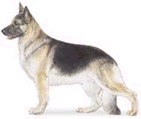

German Shepherd: He’s popular for his nobility of character, purpose, and appearance. They make wonderful companions. He is active, and will be happy with you in fishing, swimming, or playing. He likes children very much.

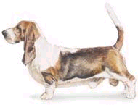

Basset Hound: Long and low, the Basset Hound is popular for his sweet personality and gentle manners. A family companion, especially for kids, the Basset is a winner.

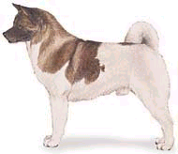
Akita: A powerful dog. Originally used to
hunt bears in Japan. Today the Japanese use the Akita as a guard dog or as a police dog.

There are special dogs:

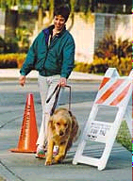
Dogs for the blind:
Guide Dogs are professionals. Their skills are well developed. They differ from pet dogs because they are trained for the express purpose of providing a safe means of mobility for people who are blind.

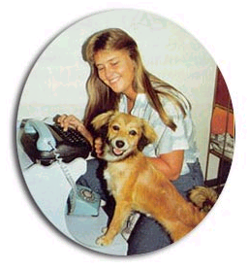
Dogs for the deaf:
Dogs learn to respond to verbal and hand signals and are taught to work for toys and affection. They are trained to make physical contact and lead their owner to the source of a variety of sounds.

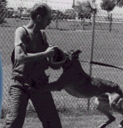Police dogs:
They very special for their obedience, intelligence, agility, search ability, and criminal apprehension.
They are trained to search for explosives, drugs,
and also rescue people.


If you want to have a dog, consider some important aspects:

- what kind of breed
- with long hair or short hair
- for outdoors or indoors
- as companion or guard
- quiet or energetic
- big or small
- color

ACTIVITY:

I Describe these dogs. Mention 2 adjectives for each breed.

The German Shepherd is _________________________________________
The Basset Hound is ___________________________________________
The Akita is __________________________________________________

II Answer these questions:

Which dog is very active? /Which is not? ___________________________
____________________________________________________________

Which dog will keep you safe? ___________________________________

Which dog is good for children? __________________________________

Which dog do you like best? Why? _______________________________
____________________________________________________________

III Describe these dogs. What are they special for? Mention their principal
characteristics.

Dogs for the Blind: _______________________________________________
_______________________________________________________________

Dogs for the Deaf: _______________________________________________
_______________________________________________________________

Police Dogs: ____________________________________________________
_______________________________________________________________

