Worksheet 1. Reading: Oldest College Graduate

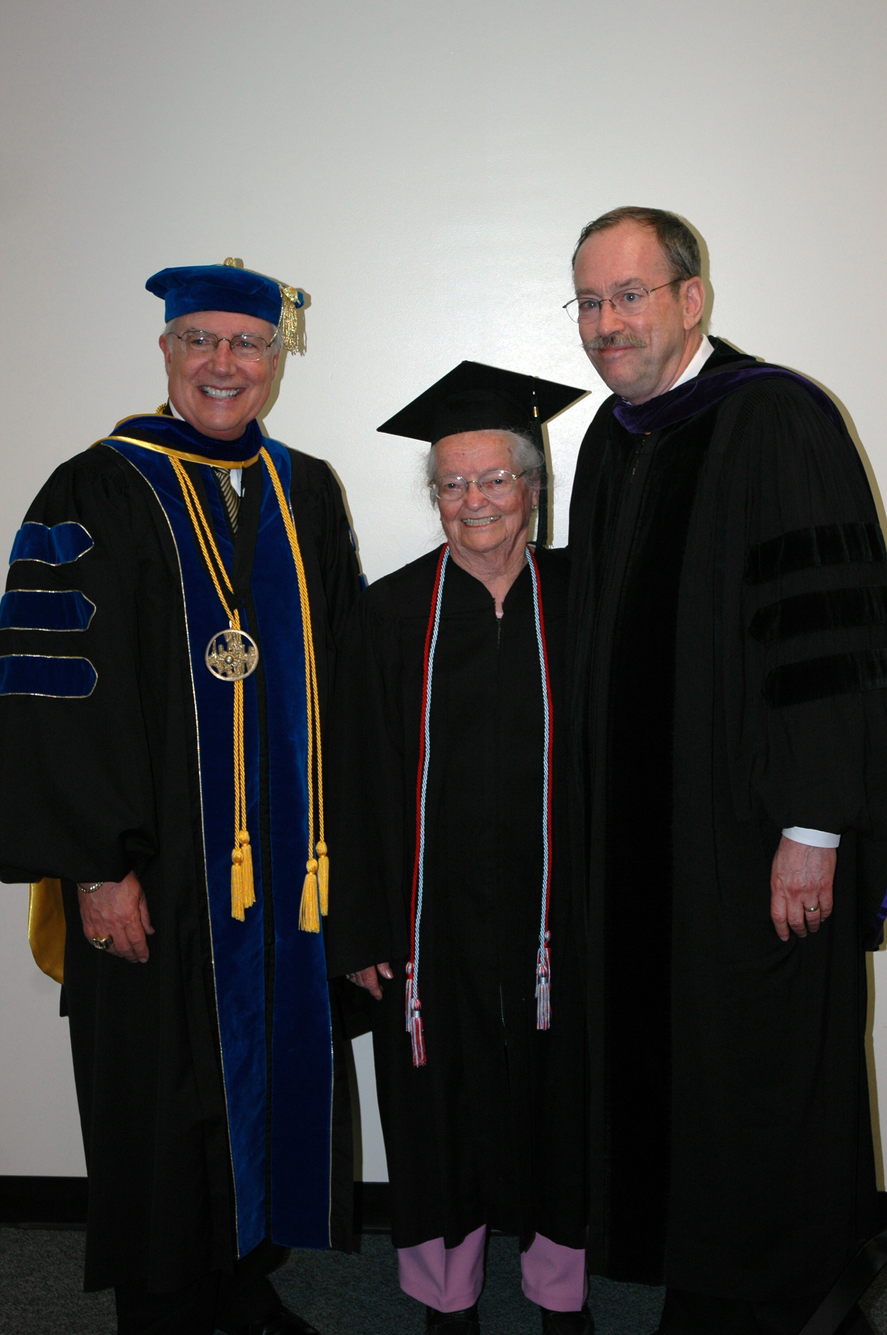
Read the passage and then answer the questions on the next page.

Oldest College Graduate

In May 2007, many thousands of graduates throughout the country received their college diplomas. At Fort Hays State University in Kansas, there was a unique graduating senior: Nola Ochs, a 95-year-old great-grandmother.

Ms. Ochs graduated from high school in 1929, but she didn’t start college until almost 50 years later, after her husband had died. Until then, she had been living and working on the family farm and raising her four sons. After the boys grew up, she attended her first college class, about agribusiness, the business of farming. She liked the college campus so much that she enrolled in many more classes.

In a radio interview with National Public Radio just before graduation she said, “I’ve taken lots of history classes, civilization classes, composition classes, public speaking and computer classes.” She has been writing her college papers on her laptop. In fact, she has written over 100 papers. Her bachelor’s degree is in general subjects with a major in history.

Ms. Ochs has accomplished a great deal, and says she is very proud of her achievements. But she is most proud of her family: three living sons, 13 grandchildren and 15 great-grandchildren. One of her granddaughters, 21-year-old Alexandra Ochs, attended the university at the same time and graduated with her.

About the future? Ms. Ochs – the oldest person who has ever graduated from college -- says she would like to get a job on a cruise ship that goes around the world.

Worksheet 1, page 2

Circle the correct answer based on the reading.


1. What is the passage about?
a. The difficulty of college
b. The oldest person who has ever graduated from college
c. Living on a farm

2. Which sentence is true about Nola Ochs?
a. She is attending college now.
b. She is going to attend college next year.
c. She has recently graduated from college.

3. Where did Ms. Ochs live before she attended college?
a. In a city in Kansas
b. On a farm
c. On the college campus

4. What was the first class that Ms. Ochs took?
a. History
b. The business of farming
c. Computers

5. What was Ms. Ochs’ major?
a. Agribusiness
b. Public speaking
c. History

6. According to Ms. Ochs, what is her greatest achievement?
a. Her bachelor’s degree
b. Her computer skills
c. Her family

7. Who was one of her classmates?
a. Her husband
b. Her daughter
c. Her granddaughter

8. Which sentence is true about Ms. Ochs?
a. She has had a job on a cruise ship.
b. She wants to get a job on a cruise ship.
c. She is not going to get on a cruise ship.

