Worksheet 6. Reading: Youth Is Our Hope

Read this excerpt from a speech at a graduation ceremony. Answer the questions that follow, according to the passage.

Youth is Our Hope

“Our answer is the world's hope; it is to rely on youth. …This world demands the qualities of youth: not a time of life but a state of mind … a quality of imagination, a predominance of courage over timidity, of the appetite for adventure over the life of ease. As I have said, in Latin America and Asia and in Europe and in my own country, the United States, it is the young people who must take the lead.” *

Choose the correct completion.

1. When a person has hope, that person believes that a good result is
(possible / impossible).

2. Your state of mind is (how you think / how your health is).

3. Rely means (lie down / depend).

4. Youth refers to (old / young) people.

5. A predominance means that something is (smaller and weaker / larger and
stronger) than another thing.

6. If you have courage, you are (not afraid / afraid).

7. If you are timid, if you show timidity, you are (not afraid / afraid).

8. If you have an appetite for something, you (want / hate) it very much.
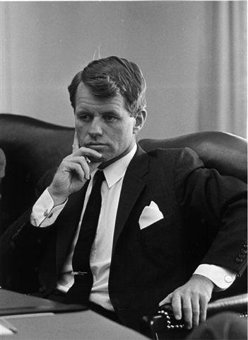
9. People who like (adventure / ease) like exciting, new things.

10. Ease is the opposite of (difficulty / west).

11. The speaker of these words (respects / disrespects) young people.

*These words are from a graduation speech by Robert F. Kennedy at the University of Capetown, South Africa on June 6, 1966.

