Worksheet 9. Using can
What kinds of activity can these people do? Complete the sentence next to each picture with the correct word of phrase from the word pool.

catch fish

do yoga
jump rope

lift weights
ride a bicycle
run in races

skate
ski

1. Andre can _______________________________________.


2. Molly can _____________________________________.
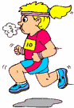

3. Ana can ______________________________________.
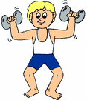

4. Jeff can _______________________________________.

5. Ali can _______________________________________.
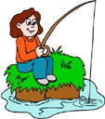
6. Marie probably can _____________________.

