Worksheet 4. Reading: Pliny Describes Elephants
Two thousand years ago, people in present-day Europe knew very little about elephants. Read the passage about elephants, closely based on the one written in the first century A.D. by Pliny the Elder in Natural History, Book 8. Then answer the questions on the next page.
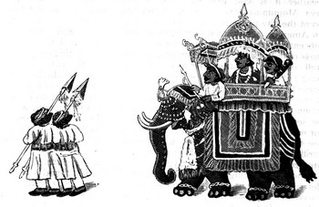
Pliny Describes Elephants
The elephant's lifespan is three hundred years. They travel in herds, are afraid of mice, and courteously salute men in whatever way they can. They once lived in both in Africa and India, but now only live in India.
Persian and Indian soldiers build wooden towers on the back of elephants and fight from there.
They possess the quality of mercy. If by chance they see a man wandering in the desert, they offer to lead him to familiar paths. If by chance they fight in battle, they want to take care of the wounded soldiers, so they take the exhausted ones and the injured ones back into their own camps.

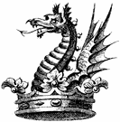
The elephant is the closest of all animals to humans in intelligence. It understands the language of its own country, so it can understand and obey orders. Elephants are wise and just, remember their duties, enjoy affection, and respect the intelligence of men. They know that their tusks are valuable, so when a tusk falls off, they bury it.

Elephants are gentle, and do no harm unless someone provokes them. Male elephants are used in battle, carrying castles full of armed soldiers on their backs. The slightest squeal of a wild boar can frighten them. They hate mice and refuse to eat food that a mouse has touched. The main natural enemy of elephants is the terrifying dragon.

Fact: An elephant has one trunk and two tusks, one tusk on each side of its trunk. They live in groups called herds.
Definition: A dragon is a large imaginary animal that has wings and a long tail and can breathe out fire.

Worksheet 4, page 2
Answer the questions according to the reading. Circle a. or b.

- What can you say about this passage?

a. The information is up-to-date and accurate.
b. The passage was written 2000 years ago.

- According to this passage, how long do elephants live?

a. About 300 years.
b. About 100 years.

- The author believes which idea?

a. Elephants come from India, but are spreading throughout India and Africa.
b. Elephants used to live in Africa and India, but now they live only in India.

- Which statement seems to be true?

a. The author believes that elephants have human qualities.
b. The author doesn’t like elephants.

- The author makes certain statements about elephants. Circle the ones that you think are scientifically true.

a. Elephants travel in herds.
b. Elephants courteously salute men.
c. Elephants want to take care of wounded soldiers.
d. Elephants are wise and just.
e. Elephants know that tusks are valuable.
f. Elephants have tusks.
g. Elephants’ natural enemy is the dragon.

- The author is describing elephants in a certain activity. What is this activity?

a. farming
b. war

- The author says that elephants are afraid of some things. Circle the things that elephants are afraid of, according to the author.

a. mice
b. wild boars
c. dragons
d. people

