Worksheet 6. Vocabulary practice

Choose a word from the word pool that completes each sentence correctly.

awhile
board
bottomless
cruise
edge
extraordinary
flexible
further
furthest
provisions
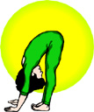
scenic
unique

1. A person who practices yoga regularly becomes
very __________________________.

2. The easternmost point is the place that is
__________________________ east.

3. Something that is ____________________ is the only one of its kind.

4. Food, drinks, and other supplies, especially for a journey, are
_______________________________.

5. You can say that something is very, very deep when you use the word
__________________________.

6. When you get on a plane, train, or bus, you ______________________ it.

7. When you travel by boat on a vacation, you’re taking a
__________________________.

8. Something that is very special, unusual, and impressive is
__________________________.

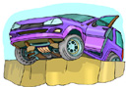
9. If you want someone to stay for a period of time, you might say, “Sit
down and stay __________________________.”

10. This car is about to fall off the _____________________
of the cliff.

