Worksheet 2. Reading: No Home on the Range

Cowboy poets often write beautiful words about their land, but some don’t. This modern poet remembers what her world used to be like, and how it has changed. She has put her thoughts into words.

Read the poem. See a picture of LaVonne, and answer the questions on the next page.

No Home on the Range by LaVonne Houlton

Well, I spent the whole day Sunday
Out a-lookin' for the range,
But I couldn't seem to find it,
For there's been a lot of change.
Where we used to pen the cattle
There's a string of new motels,
And just a bit beyond them
Stands a forest of oil wells.
Where I used to ride through sagebrush
From lunch time up to dark,
Now there's fenced-off land with signposts
Saying “Recreation Park.”
There's a freeway near the river
Where the cattle used to graze,
And the blue sky of the prairie
Has been dimmed by smog and haze.
And I couldn't help but marvel
At this thing we call "progress,"
That can change a land of beauty
To a populated mess!
Definitions
a-lookin’ - a country way of saying looking.
beyond - further away, past
dimmed - became less bright
for - a poetic way to say because
freeway - large highways
graze - eat grass as it is growing, used to talk about animals
haze - a vapor, like fog
marvel - be amazed by something
pen the cattle - use a fence to keep the animals in one place
sagebrush - a low plant that grows in the West
signposts - posts along roads that have signs on them

Worksheet 2, page 2

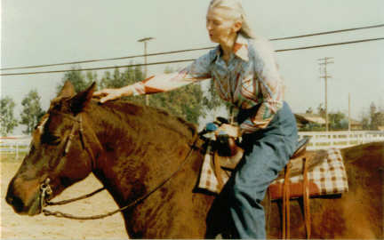

Cowboy poet LaVonne Houlton has lived in the West since childhood, and has always loved the country and horses. She spent much of her youth in the Badlands of the Dakotas, where she heard many colorful stories of the West.

Complete the sentences with the correct word or phrase.
Is there intelligent life out there?
- The author was looking for an old _____.
a. range b. deer

2. She couldn’t find it because _____.
a. she got lost b. there had been many changes

3. She found motels where _____.
a. the oil wells used to be b. the animals used to be fenced in

4. She used to ride through sagebrush, but now _____.
a. it is dark b. it is a park

5. The cattle used to graze near _____.
a. the range b. the river

6. But now, just beyond the place where the cattle used to graze, there are
_____.
a. oil wells b. blue skies

7. The air is not clear anymore because there is a lot of _____.
a. fire b. smog and haze

8. The author is unhappy because the land used to be _____, but it isn’t any
more.
a. beautiful b. dim


A string of motels

